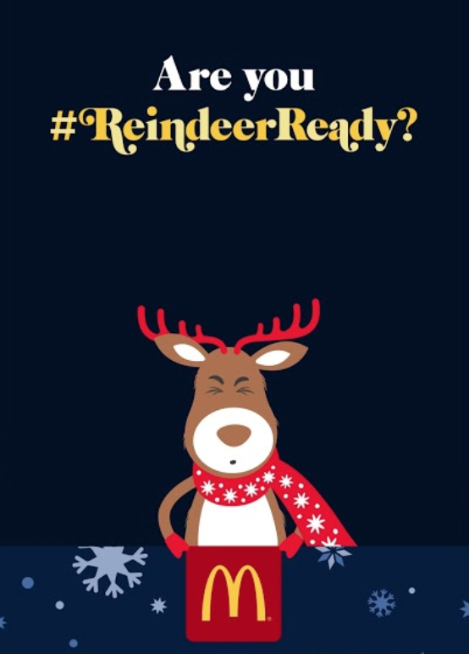
VIPERS Questions

McDonald’s Christmas Adverts 2018

#ReindeerReady

Watch the 90 second version of the McDonald’s Christmas advert 2018

Pause at the opening shot.
I – What time of year is this story set? How do you know?
(Christmas decorations)

Pause after 10 seconds
I – What night is it? (Christmas Eve)
R – What is Santa eating? (Mince Pies)
R – What do the reindeer want? (food)
IE – How does the film maker show how the reindeer is feeling? What two feelings have we seen up to now? (Hope and sadness)

Pause after 18 seconds
V – What are the reindeer pulling? (Sleigh) Can you spell it? Do you know any other words which are spelled with an ‘ei’ together?

I – How do we know the reindeer are working hard? (Panting)
E – Is Santa working hard? Explain why the film maker might want to show that Santa is having an easier time of it. (Seems like the reindeer are working even harder than they are.)

Pause after 56 seconds when Santa says, “I am tired too you know!”
P – Predict what you think the reindeer would say to him if they could.
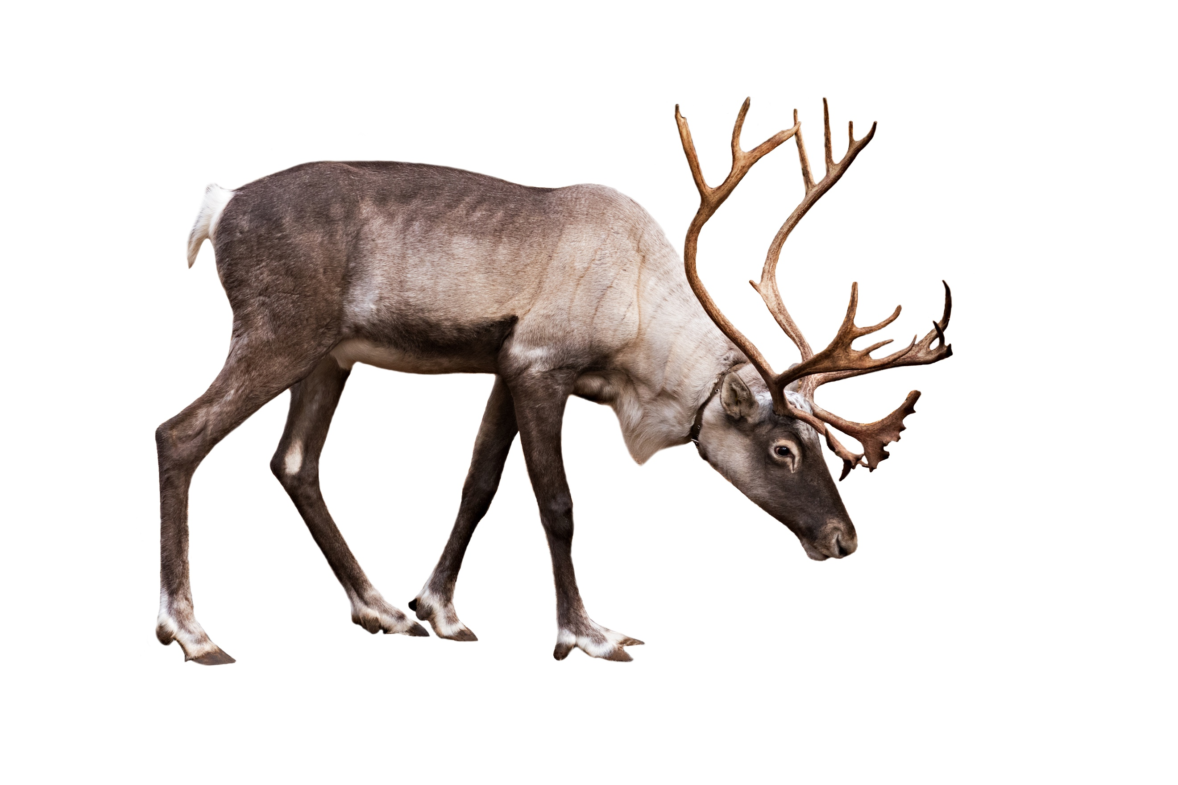
I – How do we know that the reindeer are tired? (Body language)

Pause the film at 1 min 2 seconds
P – What will Santa do next?
(Buy the reindeer McDonalds)
R – What do McDonald’s call carrots?
(reindeer treats)

